Numeracy activity: diverse families

Diverse families: data handling
Aims of the activity:

- Understand what we mean by data handling
- Show data in a chart or graph
- Understand that there are many different types of families
What is data?

Data quite simply is information that we collect and record.

Once data is recorded we can look at it and analyse it. This basically means we can use it to make discoveries.

For example, say I wanted to paint the classroom but I wasn’t sure what colour. I could ask everyone in the class what their favourite colour was. I would then analyse the data to find out the most popular colour which would help me make my decision.

Lots of people collect and use data. For example an owner of a sweet shop might look at data at the end of the month to see which sweets are most popular with customers. Then they might decide to stock more of those sweets going forward as they know they’ll sell well.

Data handling is when we present data in a way that is easy for people to understand. Often this is done using charts.

In this activity we’re going to be looking at bar charts.

Example Bar Chart
Marcie asks everyone in class 2C what their favourite flavour of ice cream is. Then she uses this data to make a bar chart to show the results.

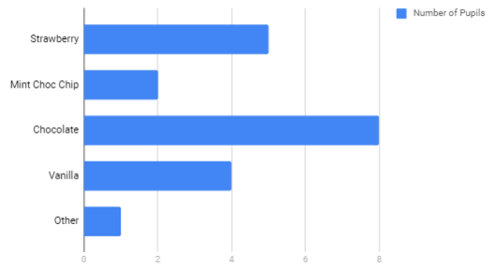
The left hand side shows all the different favourite flavours of ice cream. Marcie gave people the option to choose strawberry, mint choc chip, chocolate, vanilla or other (a different flavour that wasn’t listed).

The blue bars on the chart show how many pupils picked each option. You can tell how many pupils picked each flavour by looking at the numbers on the bottom.

Questions

Which flavour is the most popular in class 2c?

How many pupils’ favourite flavour is Strawberry?

How many pupils did Marcie ask?

Mrs Kirkpatrick’s study
Marcie’s teacher, Mrs Kirkpatrick, explains to the class that they will be learning about different types of families.

She says: “Families come in all different forms. Some people live with their mum and dad, some people live with two mums or two dads, some with just their mum or dad. Some people live with relatives who aren’t their parents”.

Mrs Kirkpatrick wants to find out about the pupil’s families. She decided the easiest way to do this is ask who they live with. Even though sometimes we might not live with the people we consider our families she thinks this might be the easiest way to collect data.

Can you help Mrs Kirckpatrick put the data into a bar chart?

Data
Marcie  Lives with her mum and dad | Jamie  Lives with his two mums | Amal  Lives with his dad | Kayleigh  Lives with her mum and dad
Enzo  Lives with his two dads | Tessa  Lives with her mum and dad | Jessica  Lives with her dad | Delali  Lives with her mum
Sam  Lives with their grandparents | Suki  Lives with her two mums | Bella  Lives with her mum | Tyler  Lives with his auntie
Bethany  Lives with her mum | Denzel  Lives with his grandparents | Hibah  Lives with her two mums | Cameron  Lives with his mum and dad
Toby  Lives with his two mums | Spencer  Lives with his mum and dad | Lottie  Lives with her mum | Bilal  Lives with his mum and dad

Make your chart
Count the different answers and put the correct numbers next to each option below.

Options | Number of pupils
Lives with their mum and dad
Lives with their two mums
Lives with their two dads
Lives with their mum
Lives with their dad
Lives with their grandparents
Lives with their auntie

Now, time to put this data into a bar chart!

Make sure you’ve got a pencil, a ruler and paper (if you have graph paper even better).

- First you’ll need to draw two straight lines, one vertical (top to bottom) and one horizontal (left to right). Make sure the vertical line is long enough to fit all 7 options.

It should look something like this:

- Down the left hand side of the vertical line write the different options i.e. ‘Lives with two dads’

- Along the bottom line you’ll need to write the numbers, starting at 0 and going up to at least 6 (as this is the highest number in the data).

Make sure the options on the vertical line and numbers on the horizontal line are evenly spaced- use a ruler for this.

- Now you can add your data by drawing the bars into the chart. Use Marcie’s ice cream graph as reference. Feel free to make them different colours if you want or decorate the bars in any way you like.

What can we tell from this data?

- Most people in the class live with their mum and dad.

- However, over half the class live in a different type of family to this.

- Would you agree by looking at this data that the families of class 2C pupils are quite diverse?

Discussion
It doesn’t matter if someone has two mums, two dads, a mum and a dad, they live with just one parent or with other relatives. A family isn’t defined by what it looks like or who it’s made up of. What matters is that there is love, support and care.

What else matters in a family?

