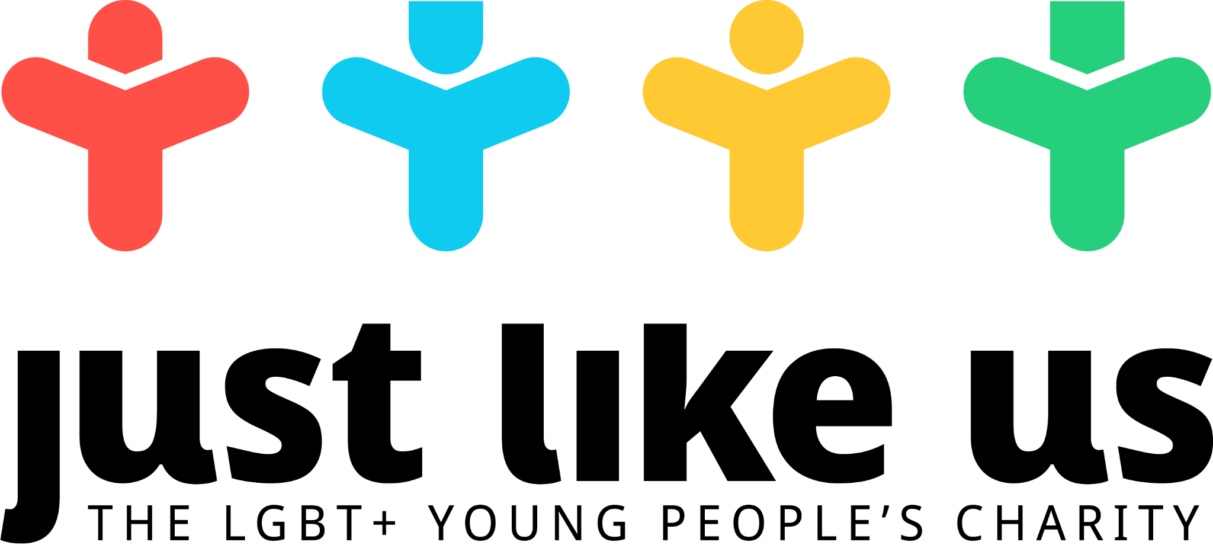

Growing up LGBT+ today
Session summary |  |  | Pupil context
This lesson focuses on gaining an insight into the experiences of young people growing up LGBT+ today. The lesson content can vary depending on which of our videos you choose to show, but is likely to explore themes such as family and friends, religion, mental health, coming out and experiences at school. Pupils can share their personal responses and the session ends on positive key messages both for LGBT+ and non-LGBT+ young people. |  |  | This lesson is suitable for secondary pupils of all ages, given that they have an understanding of what LGBT+ means.
Session aims |  | Resources needed | Link to English curriculum
- Gain insight into the experience of growing up LGBT+ person today  - Think about how I can demonstrate acceptance in my own life  - For young LGBT+ people, to see there are others who may be experiencing the same things, and see positive role models. |  | - Presentation  - Discussion prompt questions (included in presentation)  - Support resources handout (included in presentation) | The statutory PSHE curriculum for 2020 will include a requirement that pupils must understand “that healthy friendships are positive and welcoming towards others, and do not make others feel lonely or excluded”. LGBT+ specific content will also be a requirement.
Link to Welsh curriculum |  | Link to Scottish curriculum | Link to NI curriculum
“To understand the range of sexual attitudes, relationships  and behaviours in society” |  | “As I explore the rights to which I and others are entitled, I am able to exercise these rights appropriately and accept the responsibilities that go with them. I show respect for the rights of others” | “Investigate factors that influence individual and group identity”
Preparation ahead of the session
- You may need to let pupils know about School Diversity Week: you can find explainer slides in our resource library.

Timing | Activity | Suggestions for differentiation
0-10 | LGBT+ 101  - Begin by explaining the lesson aims  - Give pupils the LGBT+ terms worksheet, which asks them to match up the term to the correct definition | Remove ‘Gender expression’, ‘Transgender’ and ‘Cisgender’ and cover these after the matching activity.
10-40 | Meeting the Just Like Us ambassadors  - Play a series of videos showcasing the experiences of the Just Like Us ambassadors  - Emphasise that these experiences represent a small range within a range wide and diverse community, so whilst they are true to the individuals speaking, they are not representative of the whole community  - Give pupils a notes worksheet to fill in, so they can remember what ambassadors have said on a range of key areas including:  - Family and friends  - Religion  - Mental health  - Coming out  - School  - Any others they’re interested in finding out about  - After each clip, as someone in the class to summarise what the ambassador has said | A key aspect of differentiating this session will be selecting which videos to show. Our suggestions for younger pupils:  - Josh  - Toki  - Lauryn  - Kayla
40-50 | 5-5-1  - Ask pupils to reflect on their own thoughts and insights they have gained following the videos, using the 5-5-1 method. The structure for a 5-5-1 review is included in the presentation slides
50-55 | Key messages  - Present the key messages to pupils: what they should keep in mind if they’re LGBT+, and how they can be a great ally even if they don’t identify as LGBT+  - Note that when you use the word ‘ally’ you include LGBT+ people in that as well, as LGBT+ people need to support each other too
55-60 | Where next?  - Signpost pupils to resources they can use or turn to, and make sure to hand this out to every pupil at the end of the lesson  - Ask pupils to write a message on a post-it to give to school leaders outlining what they’d like their school to do for LGBT+ pupils

