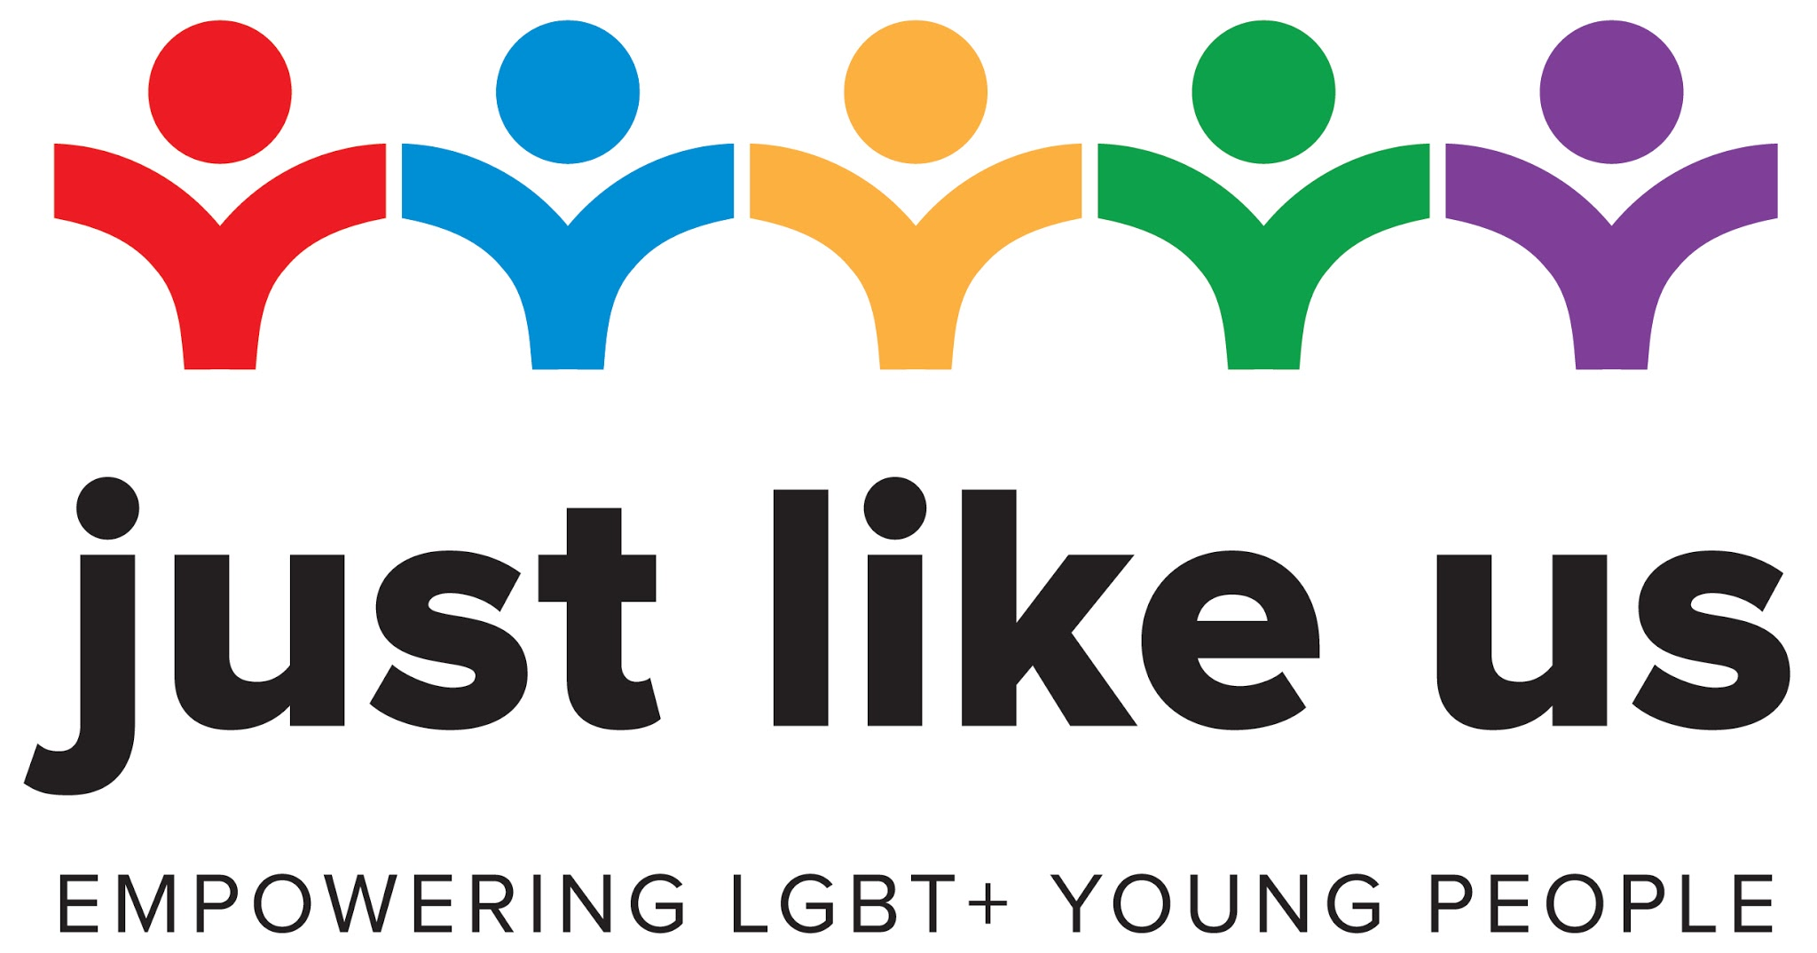

Involving parents: template messages

We have created two messages that you can send to parents, carers and guardians about the week, its importance and how they can support their child.

- Make sure to double check and personalise all content highlighted in yellow.
- Content highlighted in blue represents optional information you may or may not want to keep.
- Message two is a version of message one, but in easier-read English.

We want to make sure that every child in our school does their best. One way we are going to do this is by taking part in School Diversity Week (22-26 June), along with millions of pupils across the UK, and we need your help to make it happen.

What is School Diversity Week?
School Diversity Week is the national celebration of lesbian, gay, bisexual and trans (LGBT+) equality in education. Organised by the charity Just Like Us, the week empowers young people, parents and staff across the country to come together to recognise diversity and understanding in schools and take responsibility for tackling homophobic, biphobic and transphobic bullying.

Preventing bullying and preparing for life
Growing up remains unacceptably tough for LGBT+ young people: 40% contemplate
suicide, 52% self harm and 86% still hear homophobic remarks. This has a potentially lifelong impact on young people’s attainment and wellbeing. Alongside our anti-bullying and
safeguarding policies, taking part in School Diversity Week is an important way of actively
supporting LGBT+ young people in our school, and of demonstrating our commitment
to an inclusive school environment where every young person can be themselves and
thrive. It is a chance to explain to all our pupils the importance of diversity in the world we
are preparing them for.

It’s the law
Under the Equality Act 2010 we have a legal obligation to promote understanding about
LGBT+ equality and challenge prejudice. Ofsted will assess our approach to educating
our young people about LGBT+ issues and combating bullying. Involvement with School
Diversity Week has been commended by Ofsted as an indication that a school is fulfilling
these responsibilities.

Doing activities at home
Due to the changes brought about by Coronavirus, Just Like Us have launched School Diversity Week: Home Edition, allowing young people to take part in the safety of their homes. This Home Edition will let us provide our pupils with activities, online masterclasses and creative challenges.

Both our school and Just Like Us are taking every precaution to keep your child safe. For more details about the safeguarding measures we are taking, please contact <contact name>.

How you can help
As parents, carers and guardians, we need your support to make sure your child makes the most of the week. We would love for you to:

- Continue supporting your child in completing the activities we upload to our remote learning platform
- Attending the online masterclasses we’ll be encouraging all pupils to watch - these are tailored to primary aged pupils and led by an experienced facilitator. Don’t forget to remind your child when these are to take place so that they don’t miss out, and help to direct them to the video
- Just Like Us is running a daily photo challenge (there will be details on Twitter, Instagram and Facebook) that anyone can get involved with - each day will have a different theme so there’s something new for you to do every day. This will probably include helping your child to find something suitable to photograph, taking the photo and sending it to info@justlikeus.org or <a named contact in your school>

If you have any questions at all, please contact <contact at school>.

All the best,

<Your name>

Message two - easy-read English

We want to make sure that every child in our school does their best. One way we are going to do this is by taking part in School Diversity Week (22-26 June), along with millions of pupils across the UK, and we need your help to make it happen.

What’s the week about?
The focus of the week is celebrating lesbian, gay, bisexual and trans (LGBT+) equality in education. It is run by the charity Just Like Us. Our school community is diverse in many ways, and this is just one of them. Growing up is really difficult for LGBT+ young people: 40% have thought about suicide, 52% have harmed themselves and 86% still hear homophobic comments. This has a potentially life-long impact on how well they do in school and in life.

Preventing bullying
We want to make sure that pupils in our school are not bullied, and we include everyone. It’s also important to prepare young people for the world beyond school, which is a very diverse place.

It’s the law
Teaching young people about being LGBT+ is included in the Equality Act 2010, the new PSHE curriculum, and how well we do it is measured by Ofsted.

Doing activities at home
Due to the changes brought about by Coronavirus, Just Like Us have launched School Diversity Week: Home Edition, so young people can take part from home. This Home Edition includes activities, online masterclasses and creative challenges.

Both our school and Just Like Us are making sure to keep your child safe. For more details about safeguarding please contact <contact name>.

How you can help
As parents, carers and guardians, we need your support to make sure your child makes the most of the week. We would love for you to:

- Support your child to complete the activities we upload to our remote learning platform
- Come to our online masterclasses for young people - these are designed for primary aged pupils
- Take part in the daily photo challenge (there will be details on Just Like Us’s Twitter, Instagram and Facebook). You can help your child find something to photograph, take the photo and send it to info@justlikeus.org or <a named contact in your school>

If you have any questions at all, please contact <contact at school>.

All the best,

<Your name>

