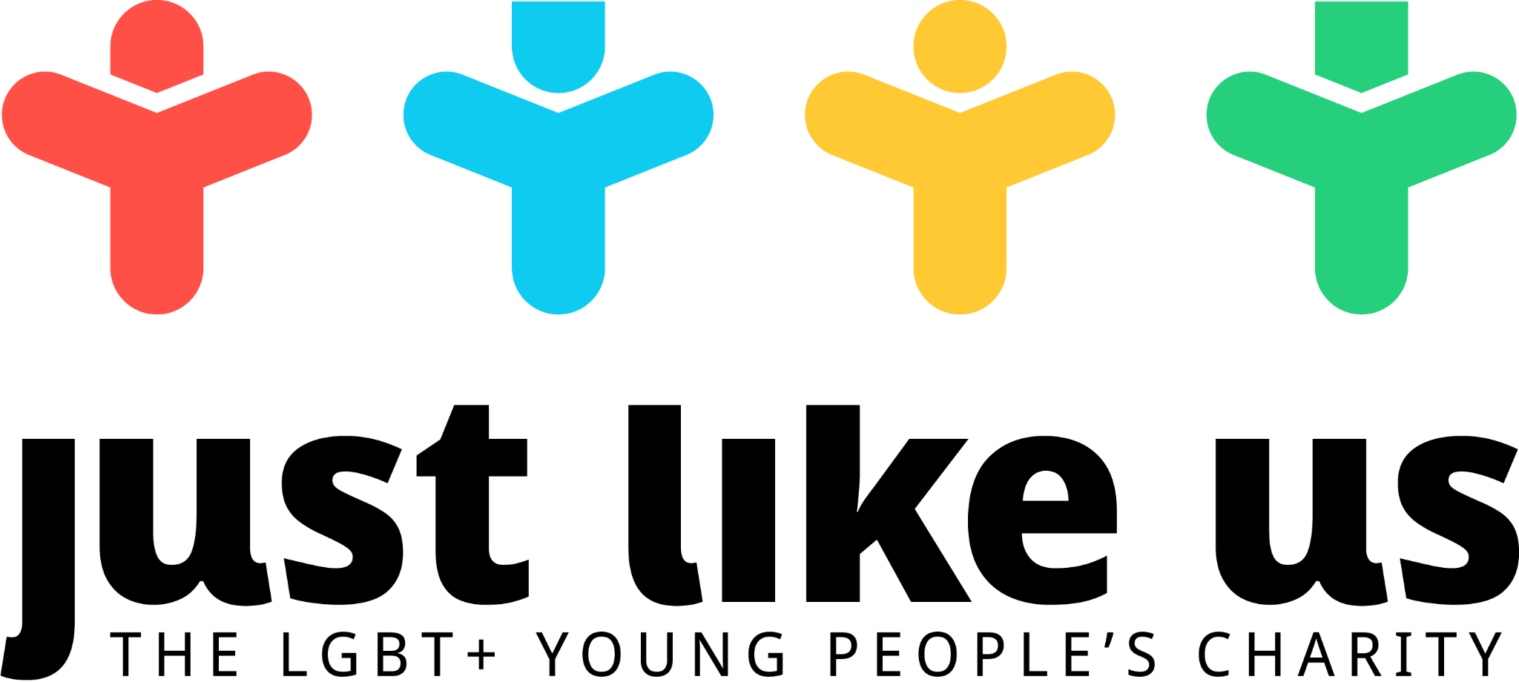

Lesson plan: how have attitudes changed in the UK?
Session summary |  |  | Pupil context
In this lesson, pupils will begin with a quick quiz on current attitudes towards LGBT+ people today. They will then explore key historical developments in the UK, followed by a closer look into the attitudes and social movements which have influenced or opposed progress. The lesson ends by acknowledging that our attitudes today are more often shaped by a more nuanced understanding of people’s experiences, and asking pupils to think ahead to the future. |  |  | Pupils will need some prior context of what it means to be LGBT+ (although this can be covered at the start of the lesson). Sources are more suitable for older KS3 pupils.
Session aims |  | Resources needed | Link to English curriculum
- Understand how attitudes in the UK towards LGBT+ people have changed over time, and which factors have driven this change |  | - Presentation  - Scavenger hunt  - Timeline  - Sources (in presentation) | “Understand historical concepts such as continuity and change, cause and consequence”
Link to Welsh curriculum |  | Link to Scottish curriculum | Link to NI curriculum
“Pupils should be given opportunities to recognise the characteristic features of the periods, situations and societies studied and the diversity of experience within each one” |  | “I can explain how the  different beliefs that people have, including beliefs which are independent of religion,  relate to their moral  viewpoints and how this  leads them to respond to  moral issues” | “Investigate the past and its impact on our world today through an understanding of:  - different perspectives and Interpretations;  - cause and effect;  - continuity and change;  - progression and regression”
Preparation ahead of the session
- You may need to let pupils know about School Diversity Week: you can find explainer slides in our resource library.
- Our intro slides contain information explaining the acronym LGBT+

Primary adaptations
- Older primary school pupils who understand the concept of same-sex attraction could view a simplified version of the timeline, and answer the question as to what rights LGBT+ people have had throughout time. This could include:
- A gay, male 16-year-old
- A lesbian couple who want to live together, get married and adopt children

Timing | Activity | Suggested differentiation
0-10 | LGBT+ in the UK today  - Run a quiz about current attitudes towards LGBT+ people in the UK and awareness of their rights. You can use our presentation or turn it into an interactive Kahoot.  - Introduce the subject and themes of the lesson. | Remove or rephrase any references to legislation which might be unfamiliar to the pupils.
10-25 | Scavenger hunt  - Ask pupils to look for key information in a timeline of key events displayed around the room | Allocate particular parts of the scavenger hunt to different pupils - for instance, those which require evaluation (‘most significant’) can be allocated to more able pupils.
25-45 | Voices from the past  - Give pupils primary sources from different time periods to examine, in order to try and understand attitudes at the time  - What can you tell about the individuals or groups involved?  - Do their words reveal anything about what has influenced their beliefs?  - What are they worried about?  - What is important to them?  - What significant events were happening at the time?  - You might want to check the timeline  - Discuss the pupils’ responses to the prompt questions, and what they feel has encouraged and held back progress in the 20th century.  - The sources selected represent religious conservatism (you may want to mention the impact of homophobic colonial rule in countries previously part of the British Empire), the sexual revolution and generational change, and social conservatism of the 20th century | Allocate particular parts of the scavenger hunt to different pupils - for instance, those which require evaluation (‘most significant’) can be allocated to more able pupils.
45-55 | Evening attitudes  - Pupils look at a quotes sheet which raises key issues for LGBT+ people in the 21st century  - Ask pupils to select one quote, and describe what issue it raises for today’s society  - Intersectionality - the different experiences of LGBT+ people within the community, for example Sam, who status as an ethnic and religious minority makes his experience more difficult than others  - Inclusion of the trans company - Bec’s quote raises the point that there is still division and a lack of understanding within the community about this, let alone in the general population  - Homophobia, lesbophobia, biphobia and transphobia around the world - Theresa May’s quote highlights Britain’s discriminatory legacy worldwide and raises questions about what role we should play in looking outside of our own borders  - The experience in rural areas - Josh’s experience reveals that there is still a major disparity between the experience of those in rural areas to those in cities, and the draw of LGBT+ people away from rural areas is probably unhelpful for supporting attitude change | Select one or two simpler quotes, such as Josh’s or Theresa May’s.
55-60 | In ten, fifty, a hundred years…?  - Challenge pupils to predict where they think we’ll be in the next century, based on the things we know about the UK today and the social changes they have seen in the last century.

