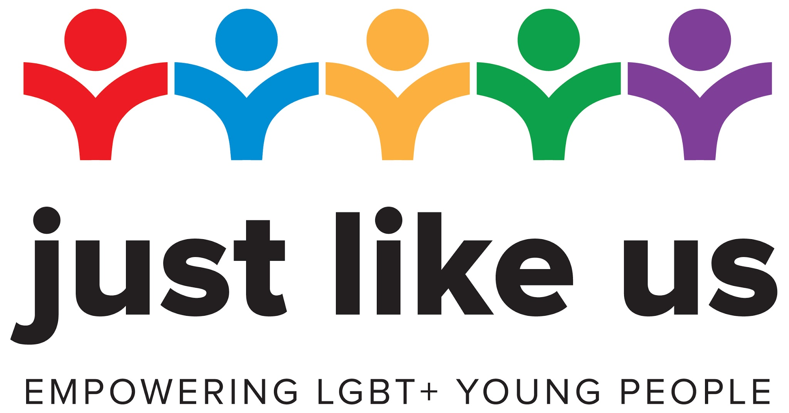

Letting pupils know: template messages

Below you can find a template message to share with pupils on your remote learning platform.

- Make sure to double check and personalise all content highlighted in yellow.

Exciting news! We’re pleased to say we’re taking in School Diversity Week (22-26 June), along with millions of pupils across the UK.

What is School Diversity Week?
School Diversity Week is the national celebration of lesbian, gay, bisexual and trans (LGBT+) equality in education. Organised by the charity Just Like Us, the week empowers you to come together to recognise diversity and understanding in schools and take responsibility for tackling homophobic, biphobic and transphobic bullying.

This matters to everyone, whether you’re LGBT+ or not.

Preventing bullying
Growing up remains unacceptably tough for LGBT+ young people. 86% still hear homophobic remarks at school, but this halves when a school does something about it. Experiencing prejudice has a potentially lifelong impact on wellbeing and reaching your potential. We want you all to thrive at school and to do your best.

Preparing for life
It’s also a good opportunity to prepare yourselves for the world beyond school, in which you’ll meet a variety of people, and understanding how people are different is really important. It will help you get ahead in life, and that’s what we want for you.

It’s the law
It’s also the law that we offer you a well rounded education which covers LGBT+ education. There are several different legal reasons why this is the case. We do it because we want to, but the fact it’s the law just shows you how important it is.

Doing activities at home
Due to the changes brought about by Coronavirus, Just Like Us have launched School Diversity Week: Home Edition, allowing you to take part at home. The week will include activities, online masterclasses and creative challenges.

Staying safe
Both our school and Just Like Us are taking every step to keep you safe. If you have any worries please contact <contact name>.

What you need to do:
- Keep an eye out for the activities sent out by your teacher
- Take a look at the daily Just Like Us masterclass - a workshop led by an expert in their field (there will be details on Twitter, Instagram and Facebook), on topics such as running a campaign and film-making
- Just Like Us is running a daily photo challenge (there will be details on Twitter, Instagram and Facebook) that anyone can get involved with - each day will have a different theme so there’s something new for you to do every day

If you have any questions at all, please contact <contact at school>.

All the best,

<Your name>

