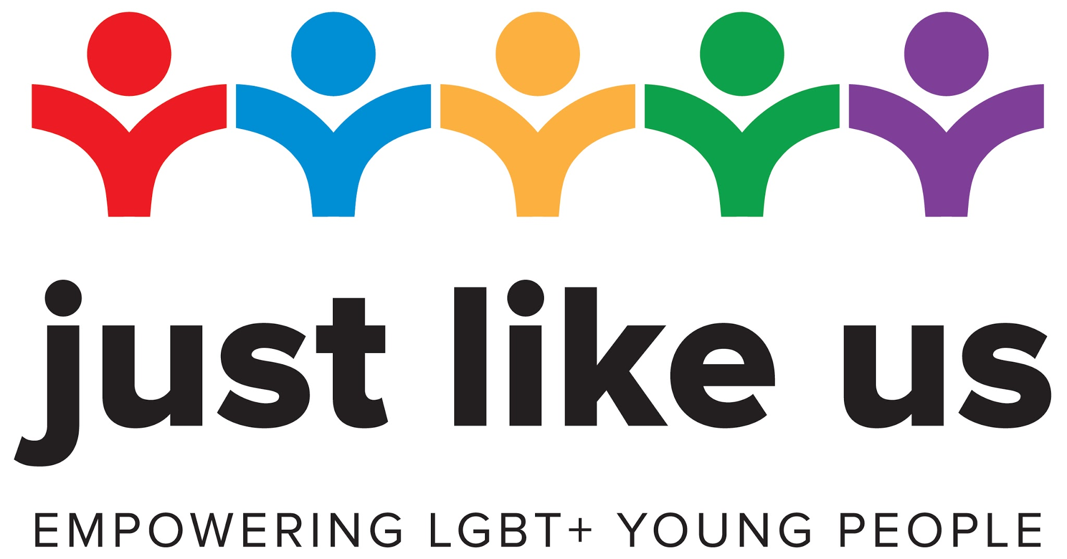

Template emails to staff

This document contains two template versions of an email to staff: more formal, and less formal.

Email to staff – more formal notification

Dear all,

<School name> is celebrating School Diversity Week 22-26 June.

This year we will be joining over 1.6 million pupils and school staff across the UK taking part in the annual School Diversity Week to celebrate lesbian, gay, bisexual and trans (LGBT+) equality in education. Section 28, which made it difficult for schools to address LGBT+ issues in a positive way, was repealed in 2003. But unfortunately, growing up remains unacceptably tough for LGBT+ young people: 40% contemplate suicide, 52% have self harmed and 86% still hear homophobic remarks.

Alongside our anti-bullying and safeguarding policies, taking part in School Diversity Week is an important way of actively supporting LGBT+ young people in our school, and demonstrating our commitment to an inclusive school environment where every young person can be themselves and thrive. It is a chance to explain to all our pupils the importance of diversity in the world we’re preparing them for.

Under the Equality Act 2010 we have a legal obligation to promote understanding about LGBT+ equality and challenge prejudice. Government guidance for the 2020 PSHE curriculum also states that LGBT+ “content is fully integrated into programmes of study ... rather than delivered as a standalone unit or lesson”. Ofsted will assess our approach to educating our young people about LGBT+ issues and combating bullying. Involvement with School Diversity Week has been commended by Ofsted as an indication that a school is fulfilling these responsibilities.

This year Just Like Us will be running School Diversity Week: Home Edition in response to COVID-19. Firstly, materials will be adapted so we can use them with pupils remotely. Secondly, there will be daily online masterclasses for young people to take part in on a range of LGBT+ topics. The resources include information about involving parents and best practice for safeguarding young people.

Don’t hesitate to contact <point of contact> to find out more about the week and share ideas about how we’re celebrating it.

<sender>

Email to staff – less formal

Hi everyone,

On 22-26 June, we’re going to be celebrating School Diversity Week!

School Diversity Week is an annual event where schools and colleges across the country celebrate lesbian, gay, bisexual and trans (LGBT+) equality in education.

Why are we celebrating it? Firstly, to celebrate what a diverse community we are, and to prepare our pupils to be citizens in a diverse world. But also to make our school/college a better place for all pupils, and particularly those who are LGBT+. Growing up remains tough for LGBT+ young people: 40% contemplate suicide, 52% have self harmed and 86% still hear homophobic remarks.

This year they will be running School Diversity Week: Home Edition, in response to school closures. Firstly, existing resources will be adapted so we can use them with pupils remotely. Secondly, there will be daily online masterclasses on a range of LGBT+ topics to which you can direct pupils. The resources include information about involving parents and best practice for safeguarding young people.

I’m very happy to answer any questions you might have about the week, and I’d love to hear your ideas about how we should celebrate.

<Sender>

